* AAA088_remesh.vtp
  + Volume: 191882.52
  + Surface area: 24854.03
* AAA088_sm.vtp
  + Volume: 191826.73
  + Surface area: 24833.33

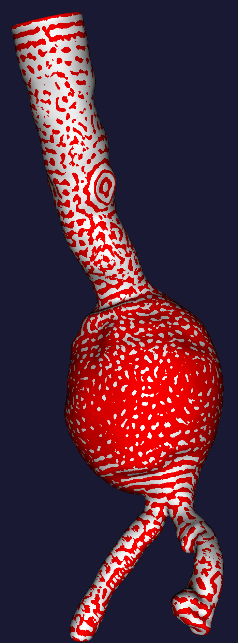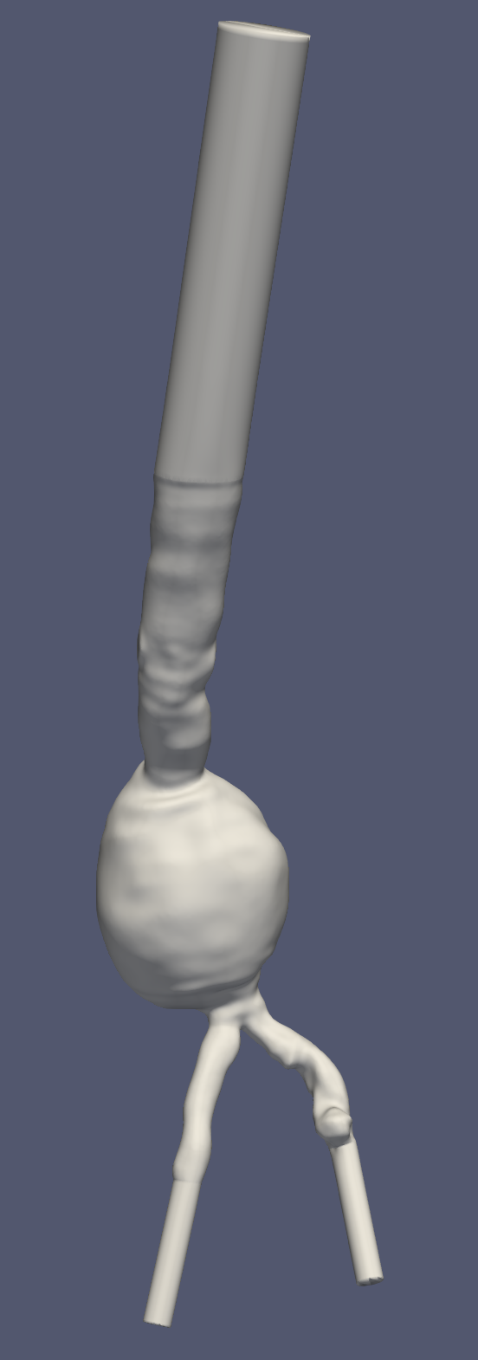

* AAA087_remesh.vtp
  + Volume: 162071.37
  + Surface area: 23921.39
* AAA087_sm.vtp
  + Volume: 162037.65
  + Surface area: 23879.85

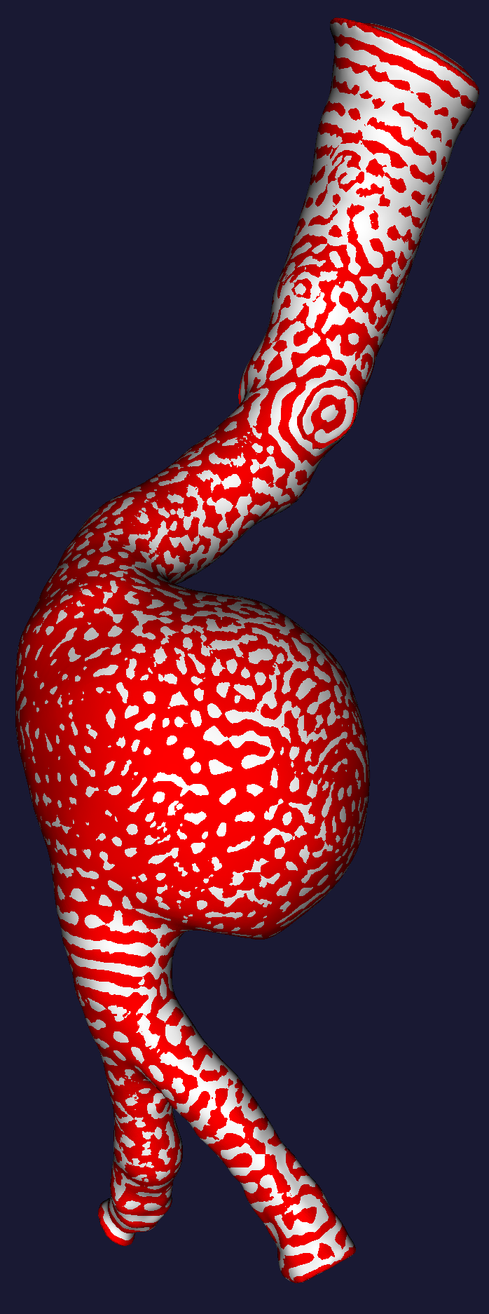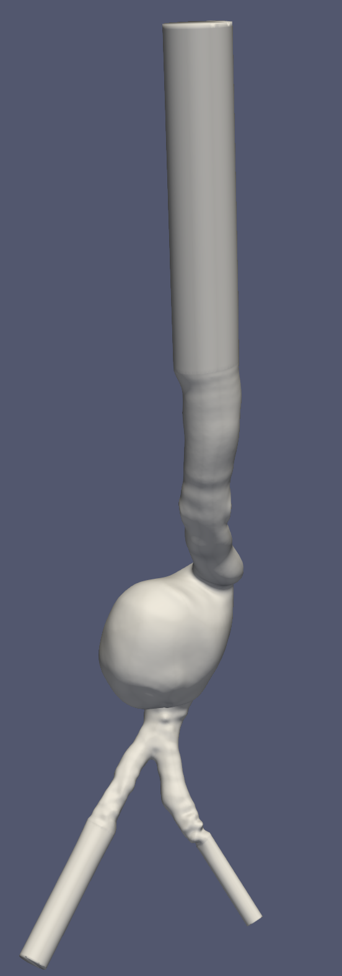

* AAA039_remesh.vtp
  + Volume: 206430.75
  + Surface area: 29001.04
* AAA039_sm.vtp
  + Volume: 206399.34
  + Surface area: 28976.30

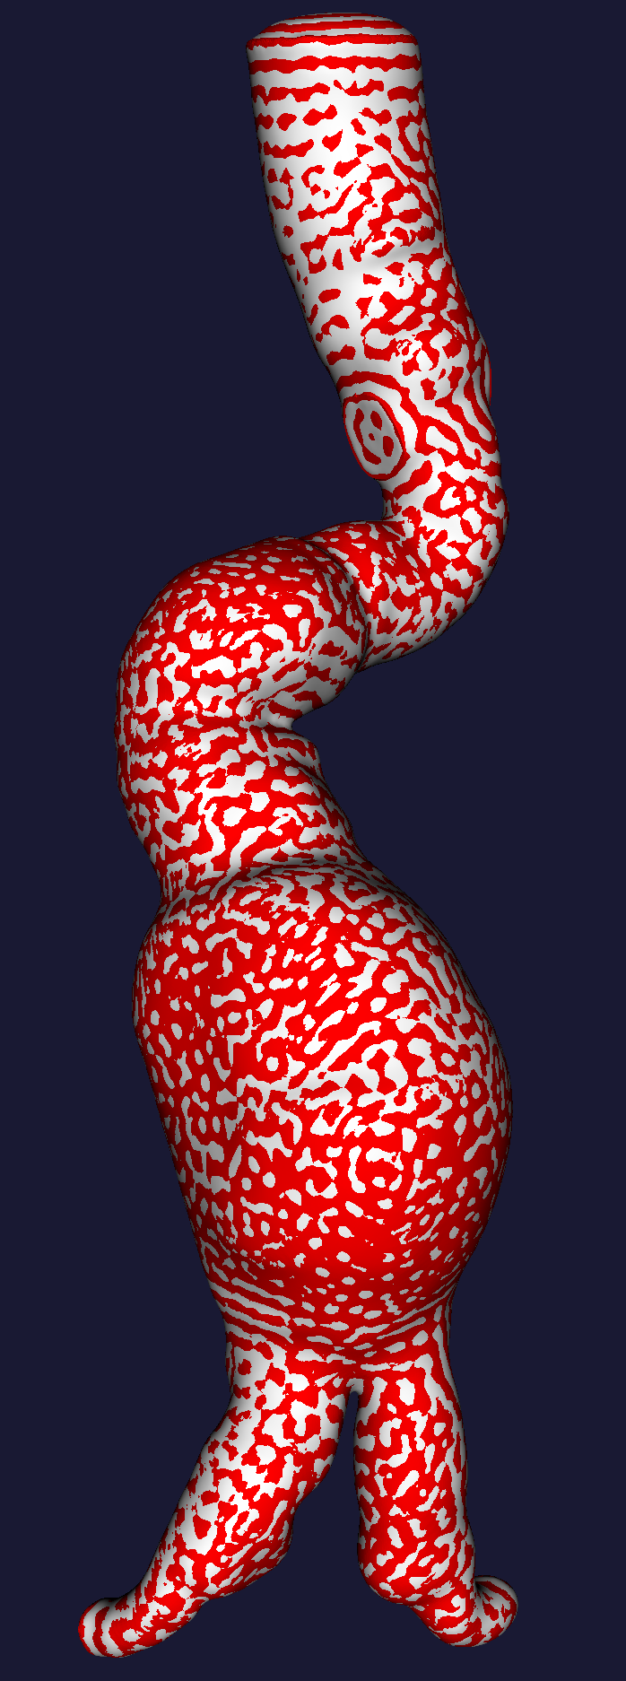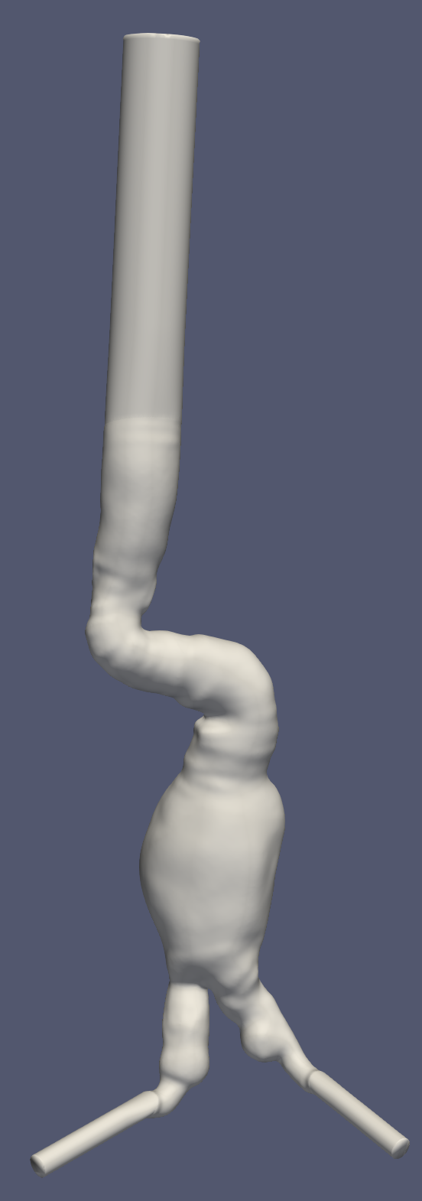

* AAA061_remesh.vtp
  + Volume: 243169.74
  + Surface area: 35745.44
* AAA061_sm.vtp
  + Volume: 243142.97
  + Surface area: 35703.38

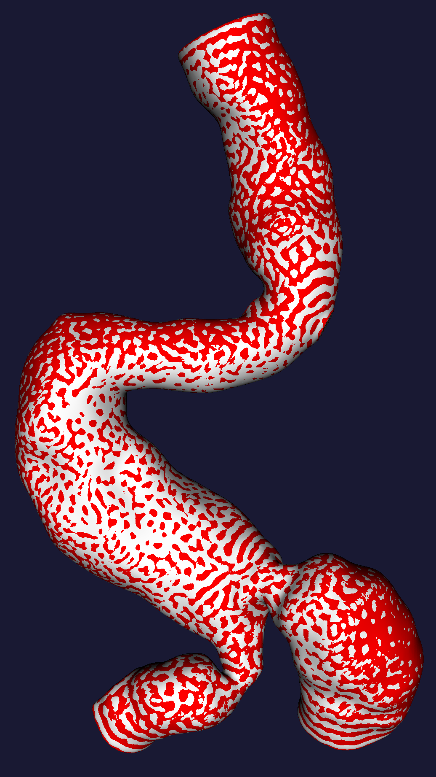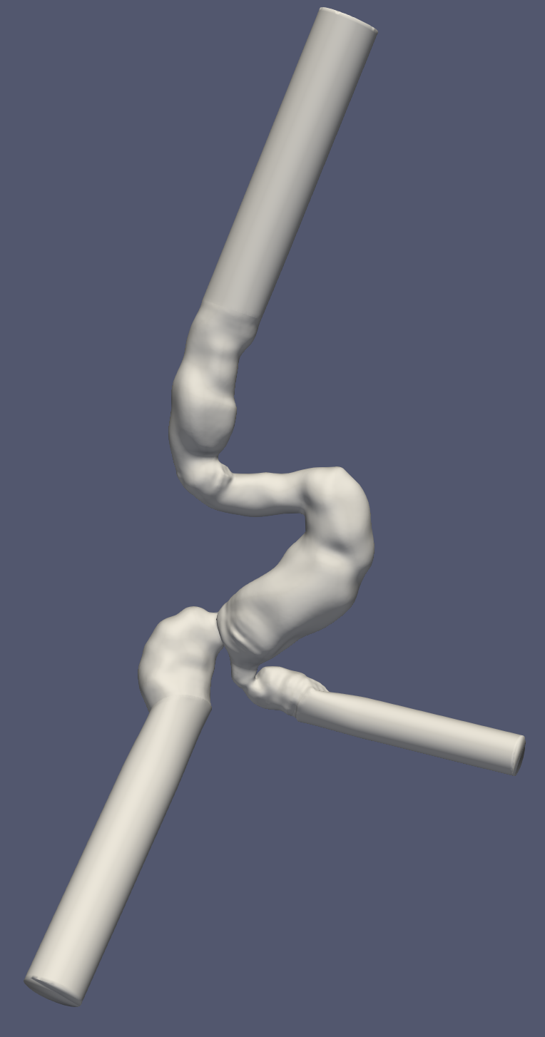

* AAA001_remesh.vtp
  + Volume: 253968.43
  + Surface area: 32233.37
* AAA001_sm.vtp
  + Volume: 253899.84
  + Surface area: 32217.41

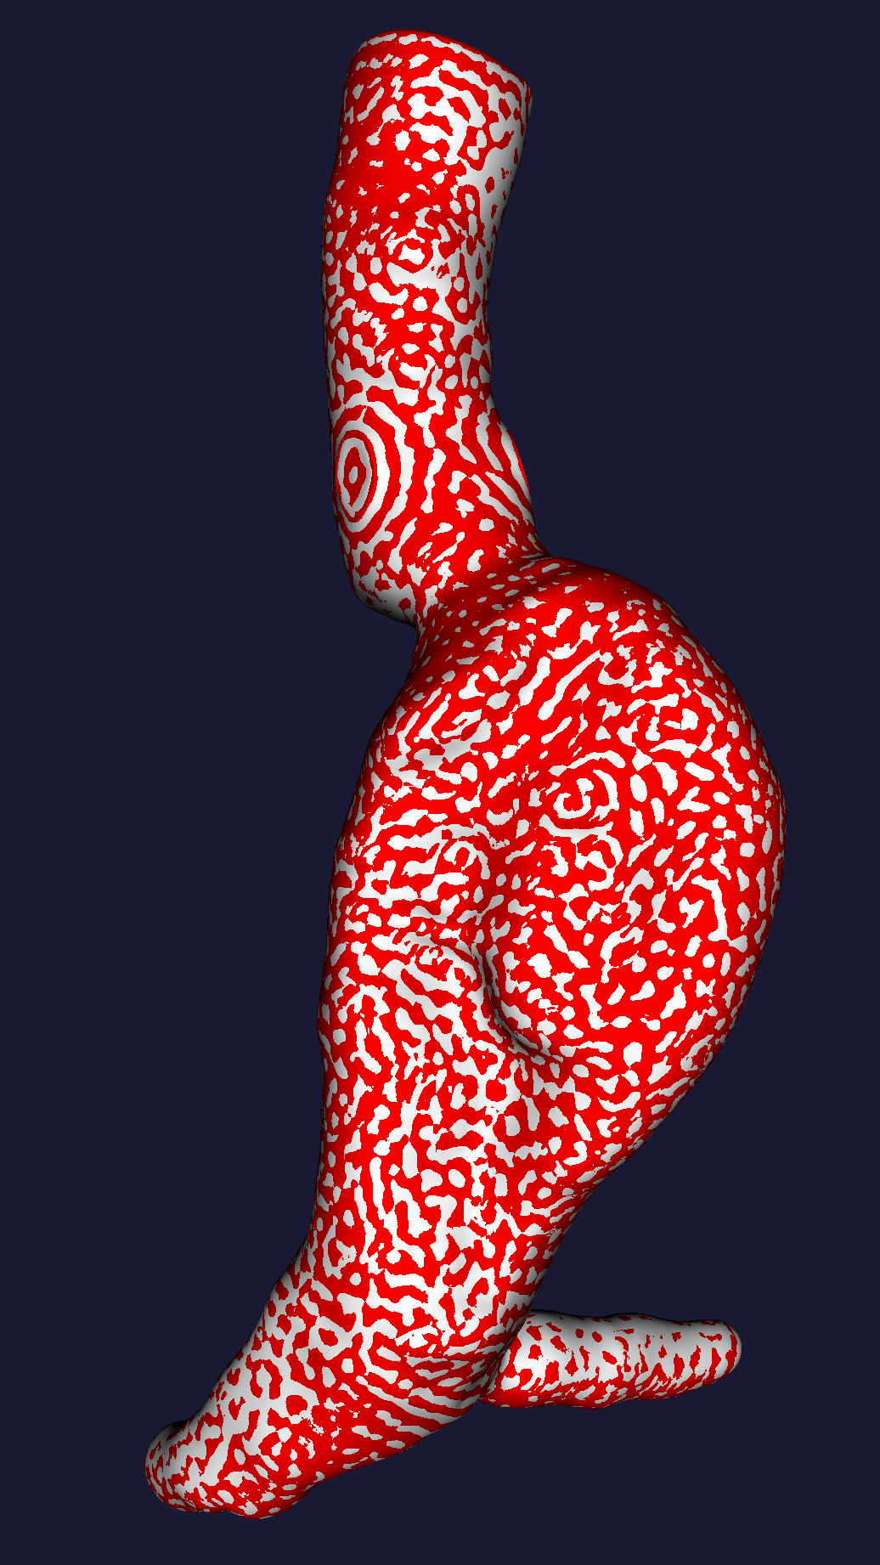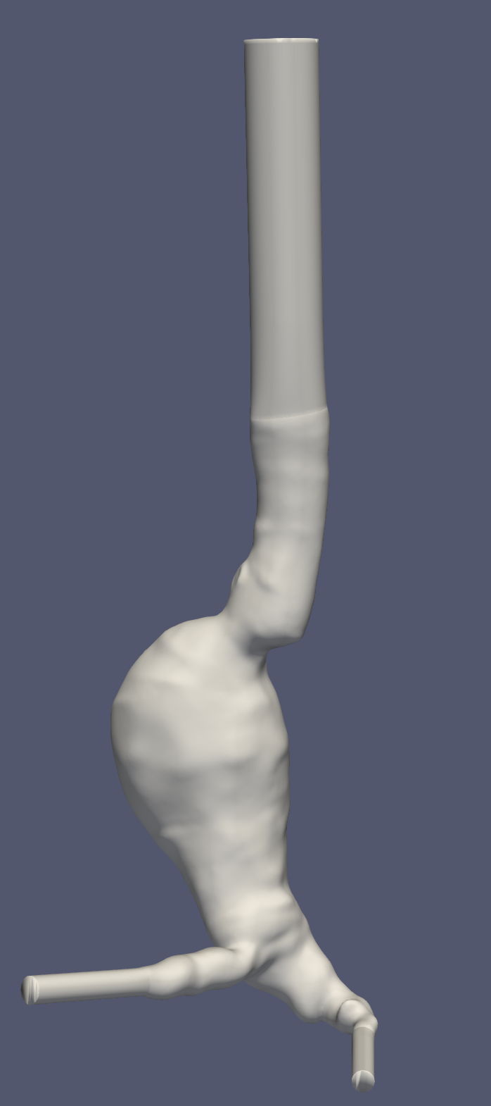

* AAA017_remesh.vtp
  + Volume: 230157.27
  + Surface area: 31146.90
* AAA017_sm.vtp
  + Volume: 230094.39
  + Surface area: 31124.51

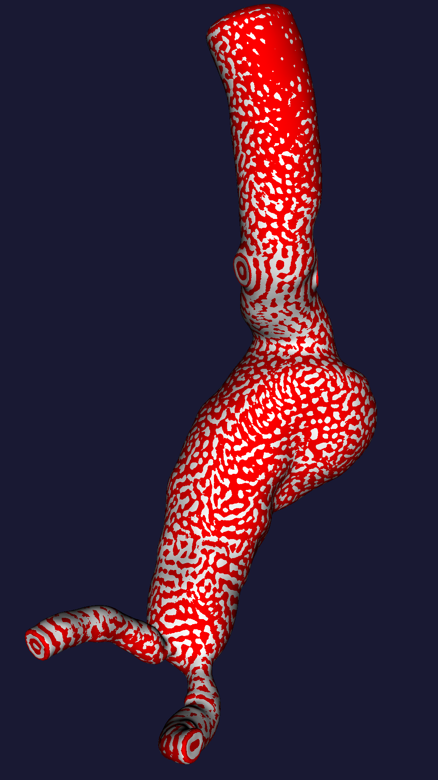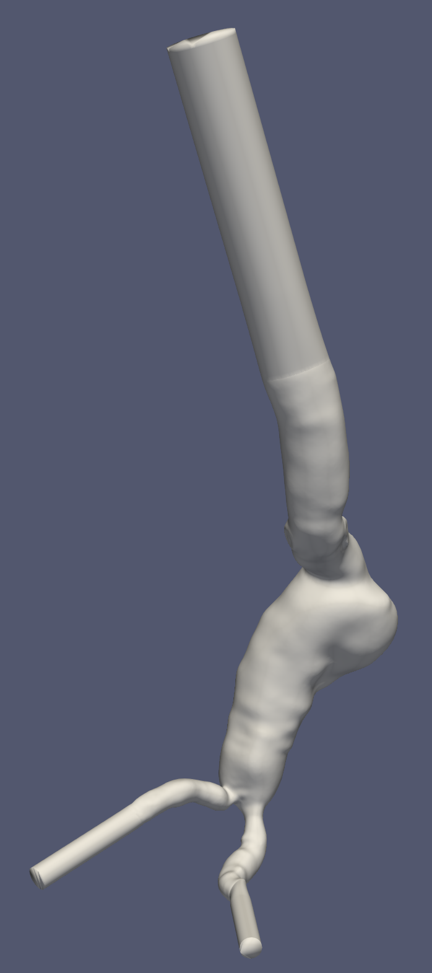

* AAA042_remesh.vtp
  + Volume: 348721.49
  + Surface area: 33963.89
* AAA042_sm.vtp
  + Volume: 348703.72
  + Surface area: 33941.26

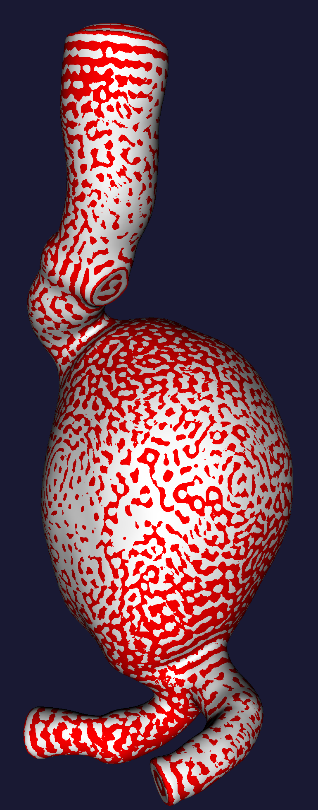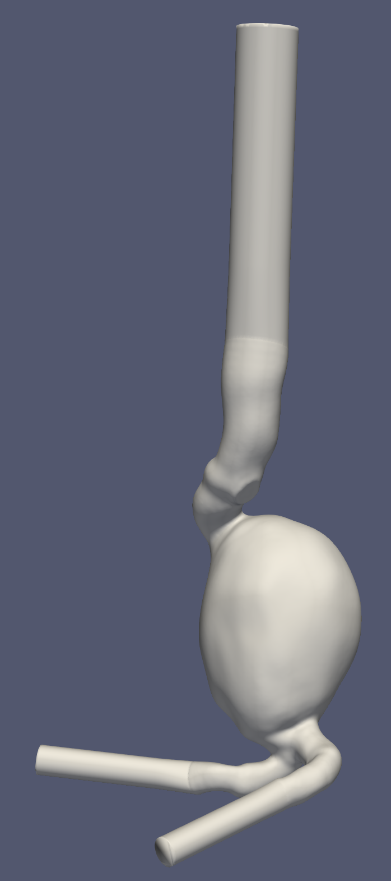

* AAA046_remesh.vtp
  + Volume: 197870.139
  + Surface area: 30031.47
* AAA046_sm.vtp
  + Volume: 197855.95
  + Surface area: 30015.76

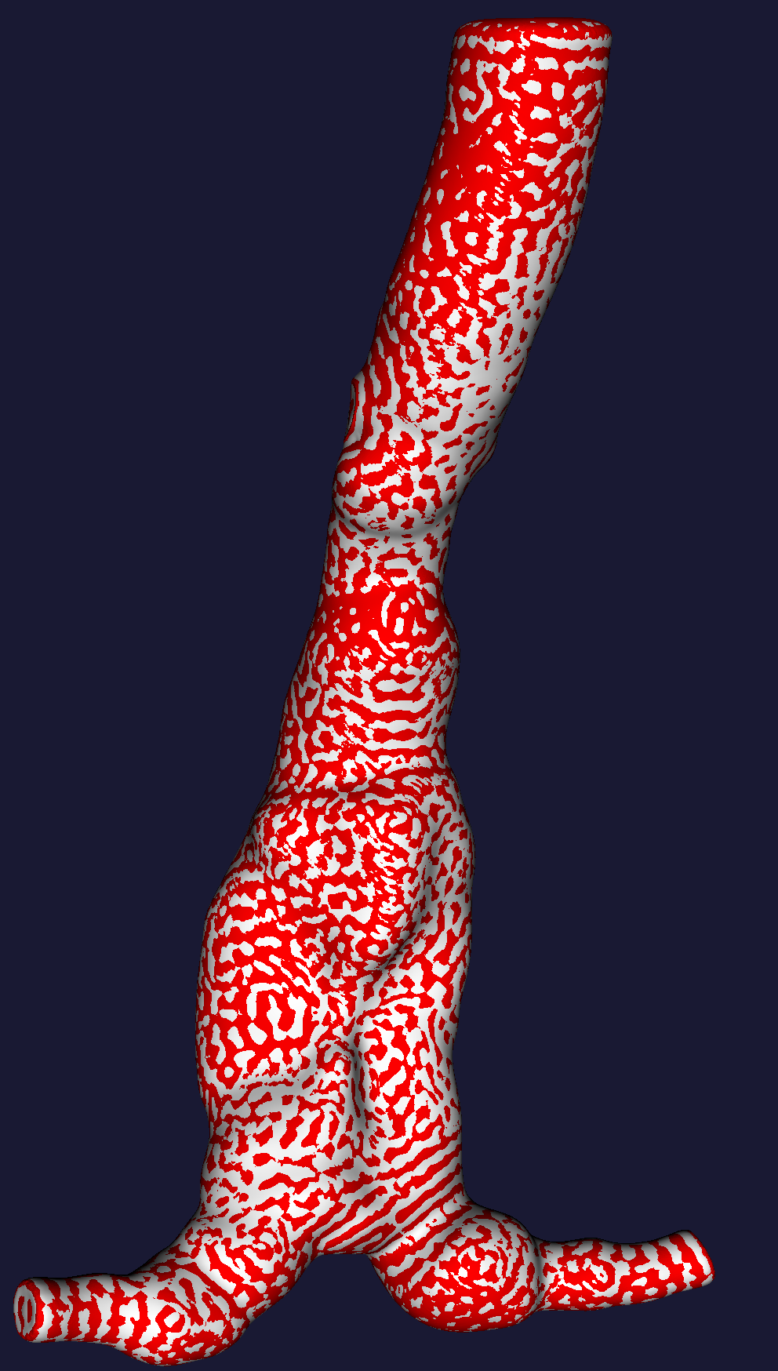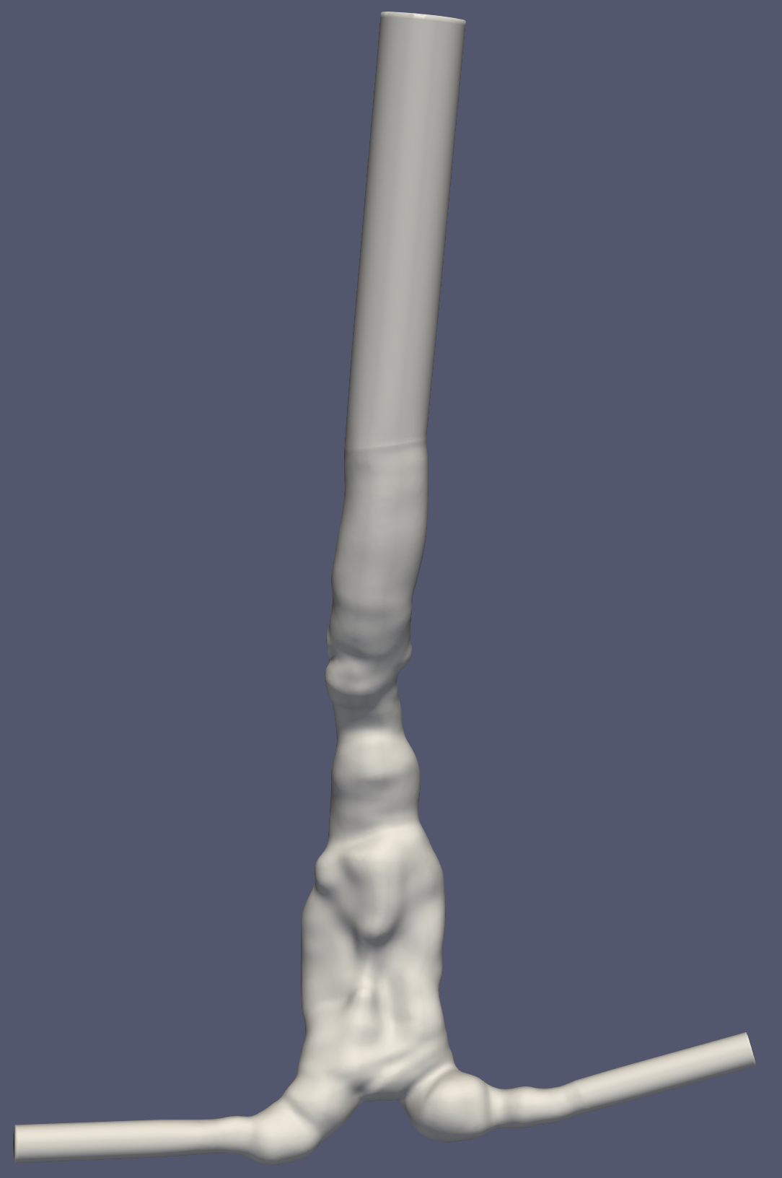

* AAA004_remesh.vtp
  + Volume: 120432.90
  + Surface area: 21478.85
* AAA004_sm.vtp
  + Volume: 120433.81
  + Surface area: 21458.50

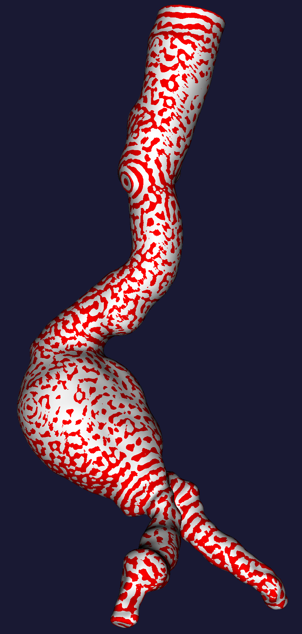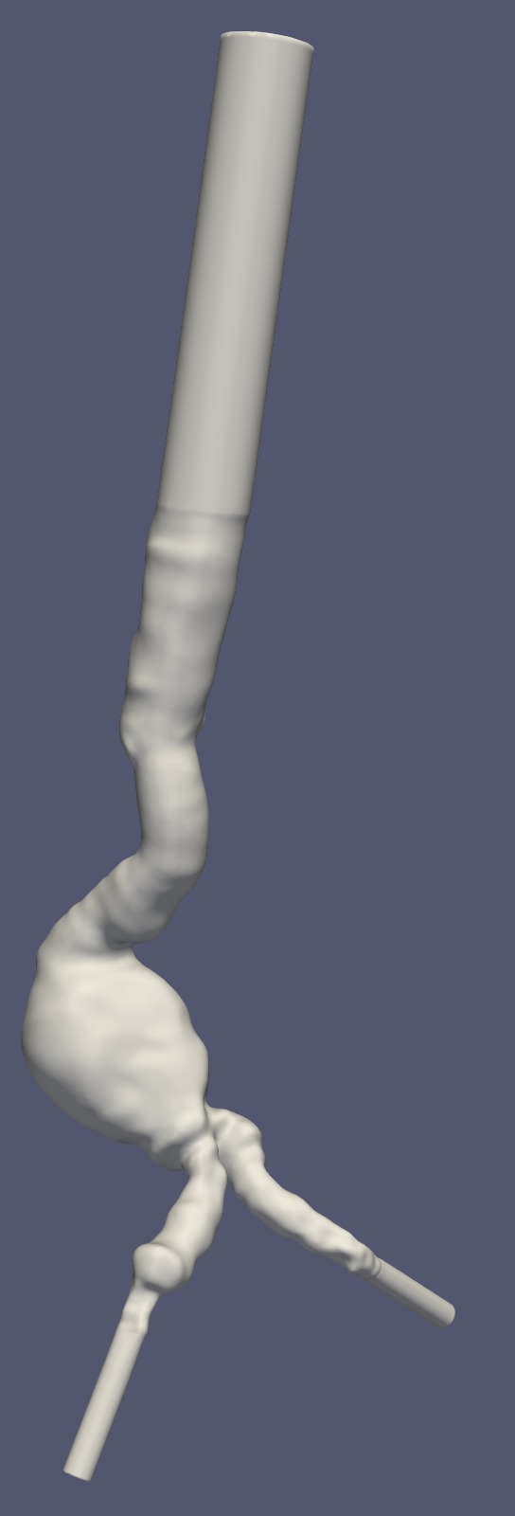

* AAA014_remesh.vtp
  + Volume: 107967.34
  + Surface area: 19908.95
* AAA014_sm.vtp
  + Volume: 107965.35
  + Surface area: 19894.68

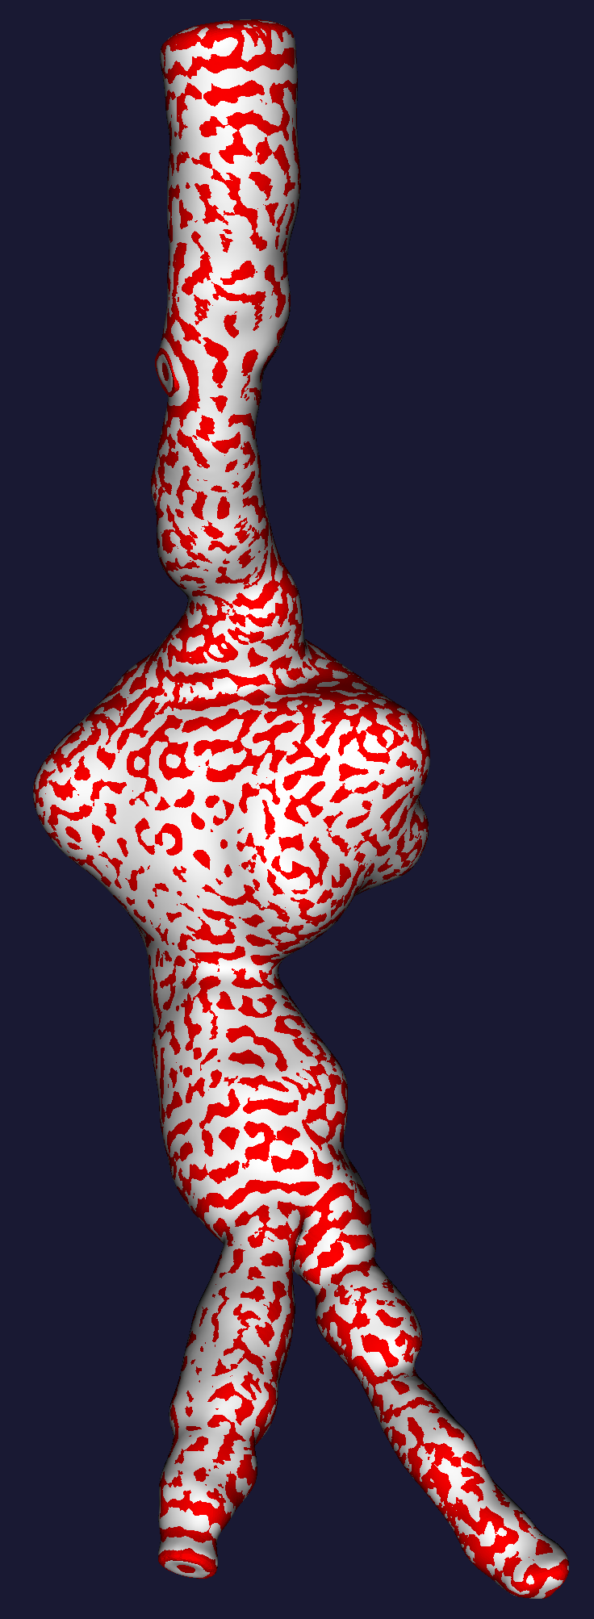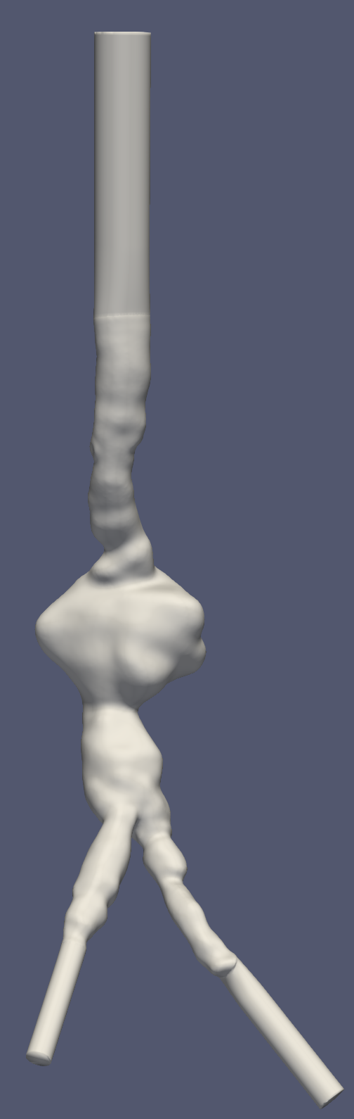

* AAA021_remesh.vtp
  + Volume: 183835.41
  + Surface area: 29027.74
* AAA021_sm.vtp
  + Volume: 183843.69
  + Surface area: 28997.46

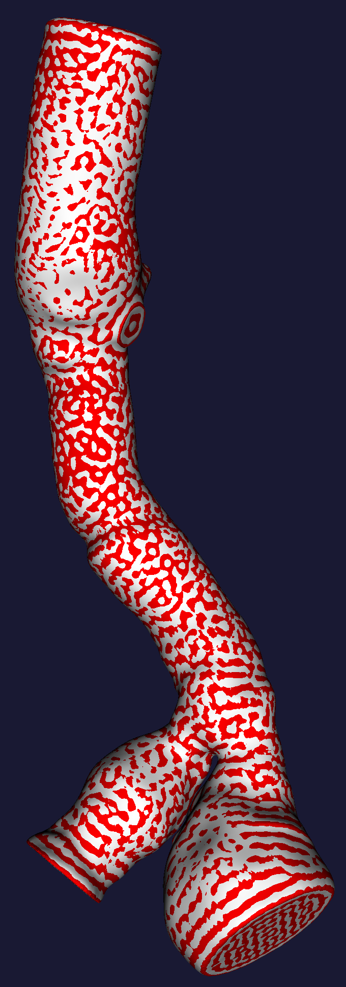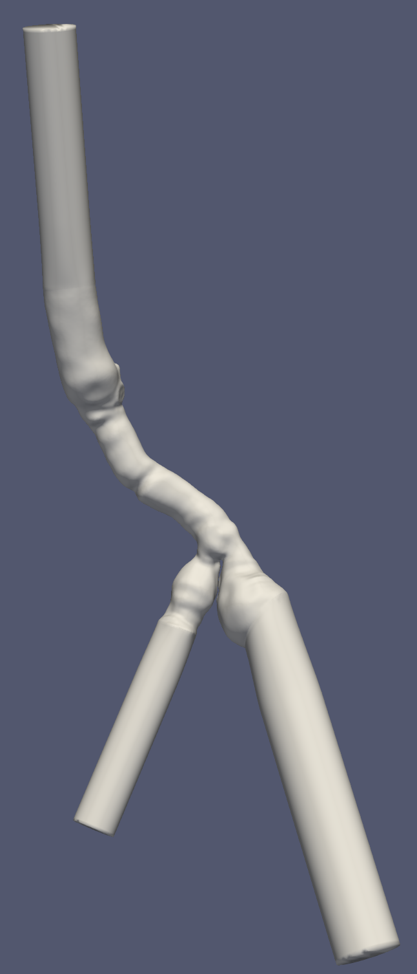ser litt rart ut med venstre iliac (den største) der extension følger centerline (antar jeg) og den er litt off

* AAA092_remesh.vtp
  + Volume: 86293.38
  + Surface area: 18363.11
* AAA092_sm.vtp
  + Volume: 86288.46
  + Surface area: 18341.05

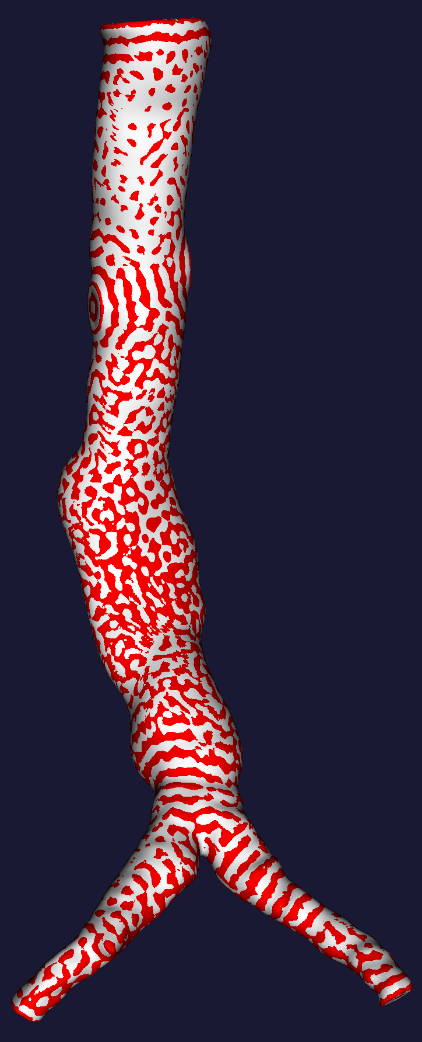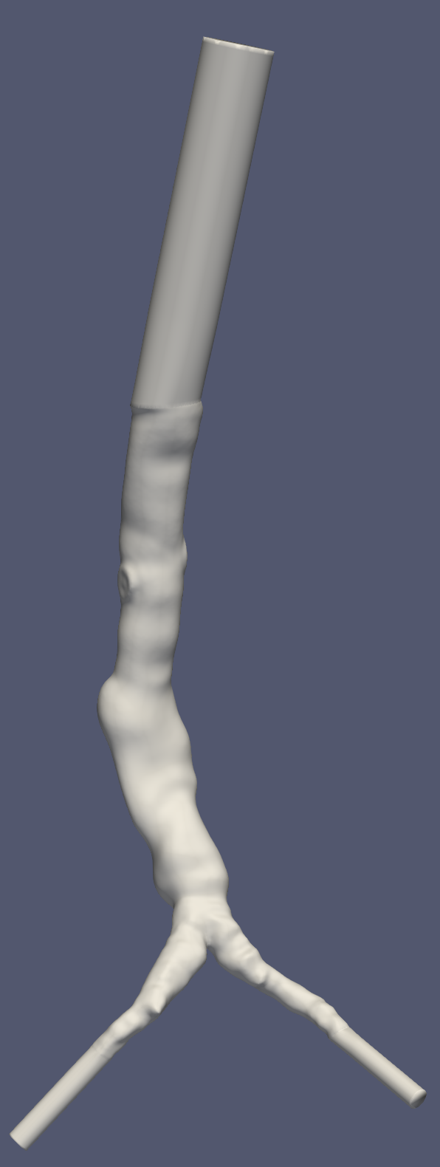

* AAA013_remesh.vtp
  + Volume: 149976.54
  + Surface area: 26341.32
* AAA013_sm.vtp
  + Volume: 149959.95
  + Surface area: 26316.43

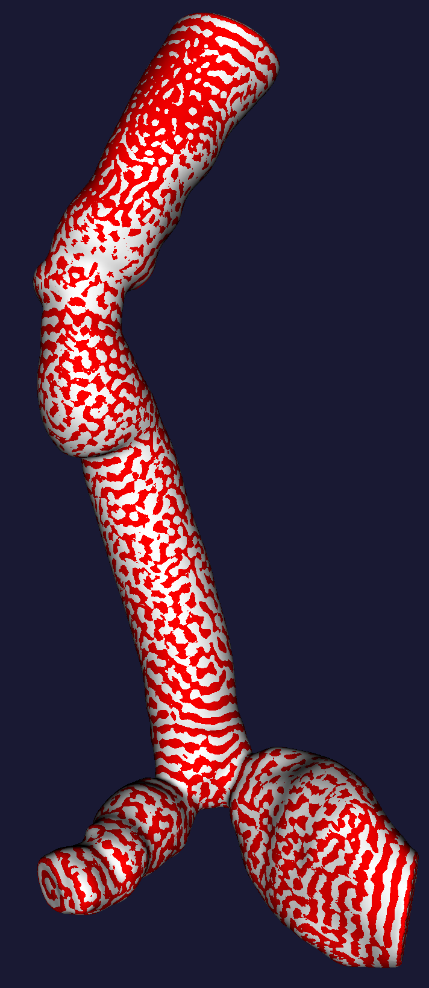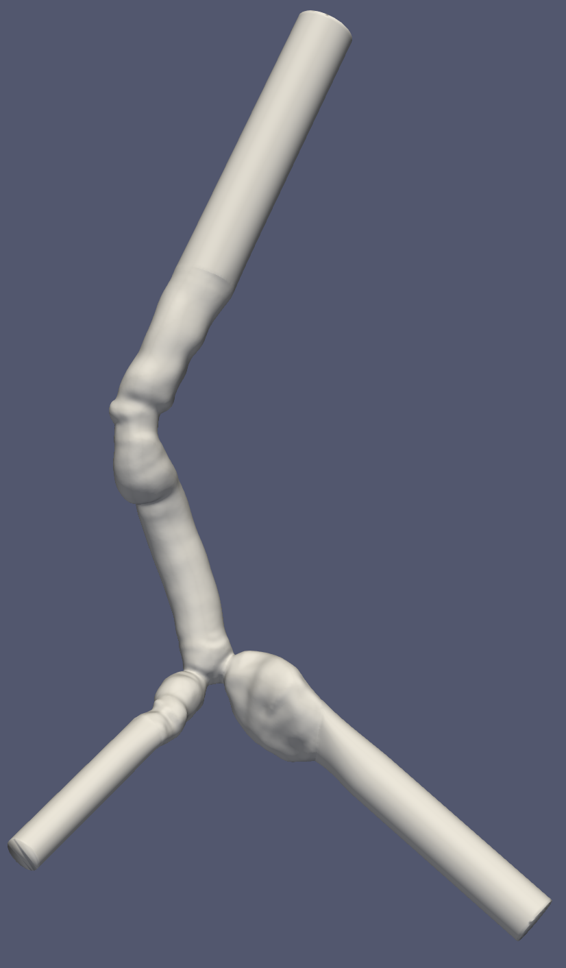

* AAA023_remesh.vtp
  + Volume: 181421.35
  + Surface area: 27650.90
* AAA023_sm.vtp
  + Volume: 181416.01
  + Surface area: 27629.38

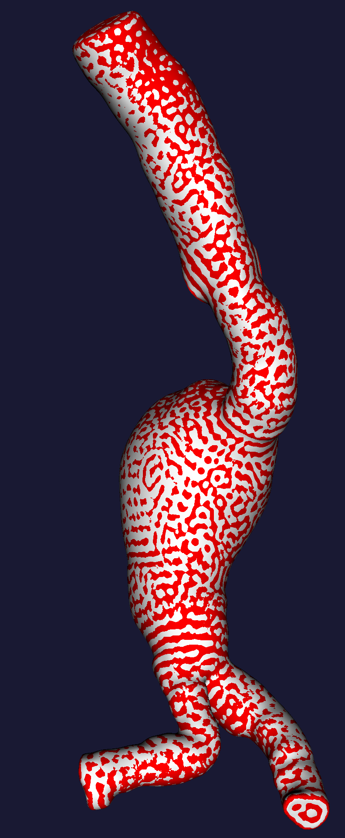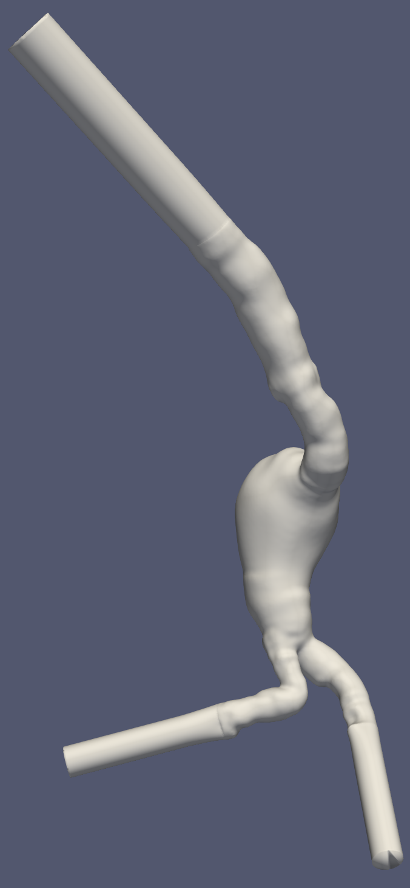

* AAA033_remesh.vtp
  + Volume: 190945.33
  + Surface area: 31284.27
* AAA033_sm.vtp
  + Volume: 190939.46
  + Surface area: 31250.66

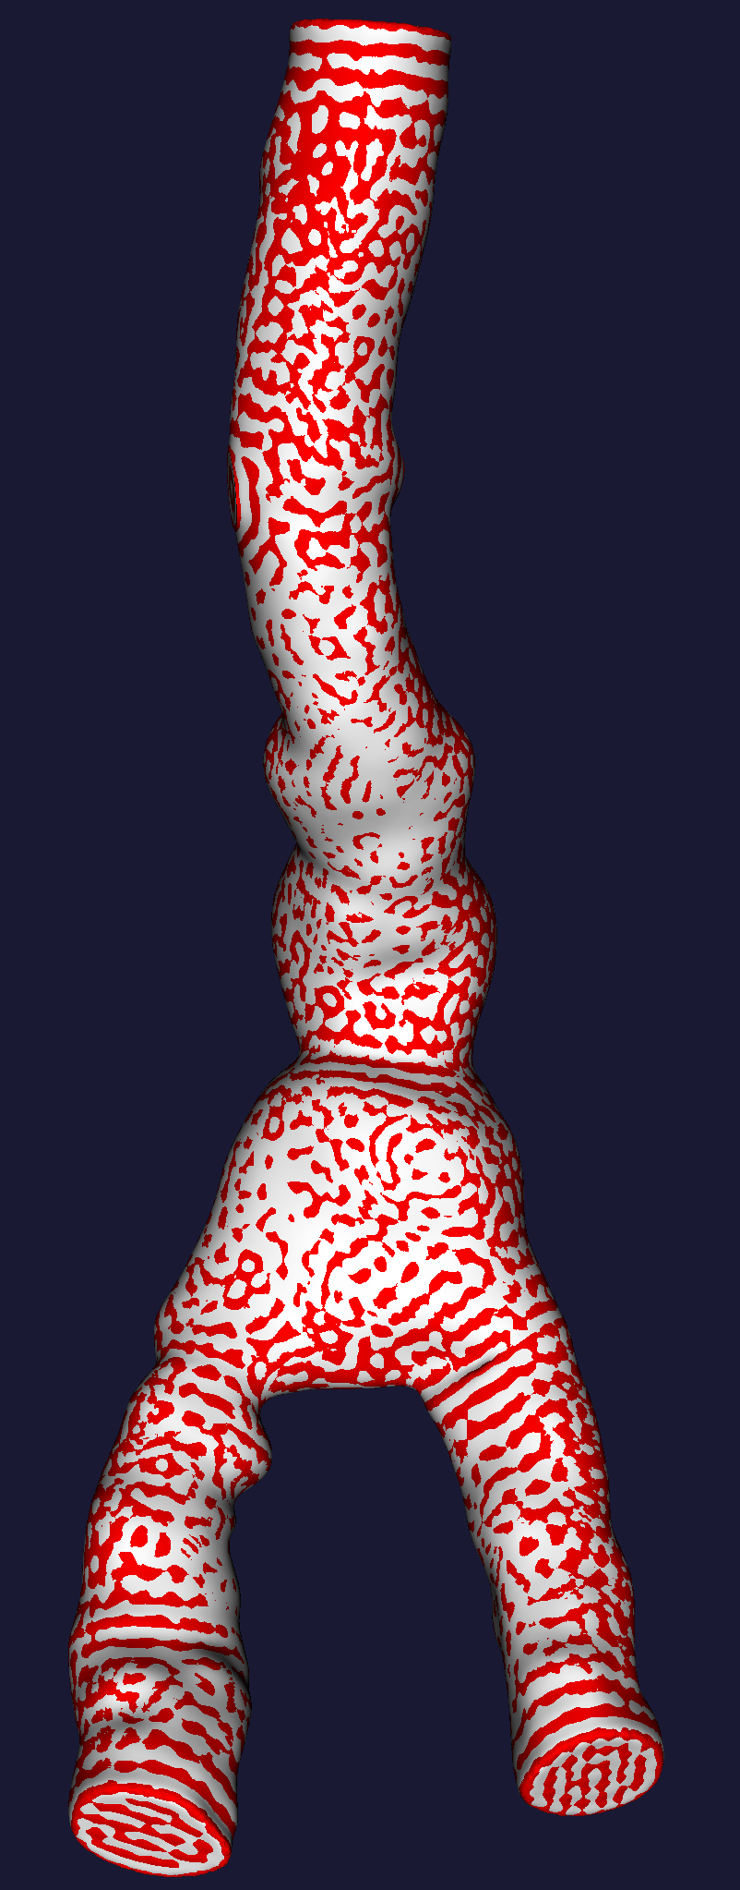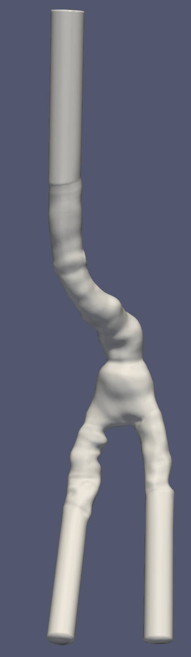

* AAA091_remesh.vtp
  + Volume: 117377.80
  + Surface area: 21255.68
* AAA091_sm.vtp
  + Volume: 117336.65
  + Surface area: 21226.74

